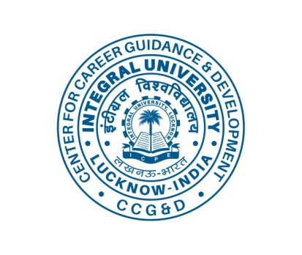 INTEGRAL UNIVERSITY, LUCKNOW

Center for Career Guidance & Development

*Creating Possibilities.......Enabling Growth*

Notice

Seminar

On

**“Management Skills for a Successful Career – College to Corporate”**

|  |  |
| --- | --- |
| Speaker | Major Ashutosh Pandey  Motivational Speaker & Trainer |
| Eligible Course | B. Sc. (All Branches) / B.Ed. / BA |
| Eligible Students | All year students. |
| **Date of Program** | **Tuesday, 21st March 2023** |
| Time | 01:30 PM - 04:00 PM |
| Venue | Hall-1, Central Library Building,  Integral University, Lucknow |
| Contact Person | Dr. Sufia Rehman - CCG&D |
| Important Note | E certificate will be issued to all participants. |

Date: 16 March 2023 Director – CCG&D

Copy for kind information to:

Hon’ble Pro-Chancellor | Hon’ble VC

HoDs (concerned) For information and departmental Notice Boards | Departmental Placement coordinators (Concerned)